Further Information

For further information, please do not hesitate to contact us
E-mail:
Telephone:
Local details:

*Further ideas for the National Month of Prayer can be found on the
1277 website www.1277.org.uk or 1277 Facebook group and 1277 National Month of Prayer Facebook group
Also, how to set up a prayer network in your area ‘Joining the dots leaflet’ is available on the 1277 website

1277 is the National Network for church-based toddler groups
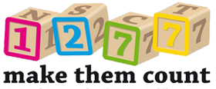

(name of your group, borough, city, area etc)

Prayer Marathon for toddler groups

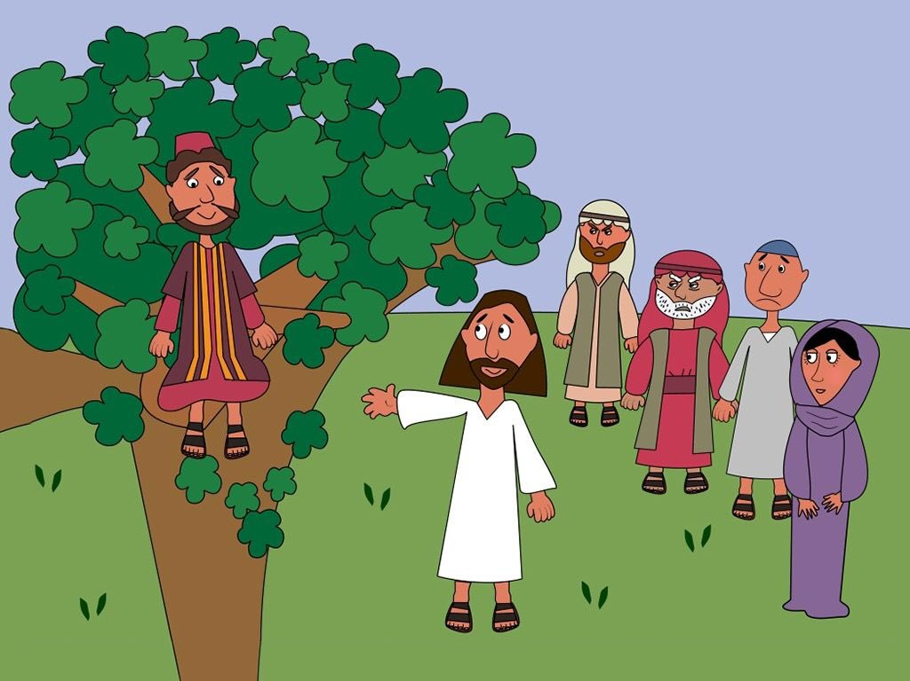

BE WARNED – prayer changes things!
Welcome one - welcome all
June 1st - June 30th 2018

June is the National Month of Prayer for Toddler groups* and for the past few years a London Prayer Marathon has taken place where one borough is prayed for each day. The boroughs were listed in alphabetical order and then prayed for. Alongside this, some toddler group leaders choose to meet together to pray. Last year several dioceses, cities, groups and towns joined in too!
If you would like to do this for your area e.g. county, diocese, city etc or for your toddler group then please feel free to adapt this leaflet to your needs. Add the details, print copies off and encourage others to join you in prayer.
How can you get involved?
1) Use the suggested prayer points and pray for a group/area/family each day (a list is provided below). The theme of this year’s month of prayer is based on Luke 10v1-10 ‘Welcome one – welcome all’.
2) Raise the profile of your group in your church ie invite the church leader and/or members to visit. You could have a slot in the service during June to profile what you do. One church in Kensal Rise, London took over the whole service and used a PowerPoint presentation and video, prayers and the sermon.
3) Connect with other toddler groups in your area over a simple lunch (bring your own sandwiches and someone provide the drinks). This could be in a local coffee shop or one of your venues. ‘Without this support, I am sure our group would have closed’ Sue, St Luke’s Drop In, Kilburn.
‘Toddler groups are a precious gift offered by churches to the wider community. In a place of welcome, relationship, play, and care, toddlers and adults are invited to experience something of the character of the living God. In this National Month of Prayer, we pray that toddler groups will provide a space for children and adults to discover more of who they are and encounter the hope and love of Jesus Christ’. Rev. Rachel Treweek, Bishop of Gloucester.

Dates | Area/family to pray for … | Dates | Area/family to pray for …
June 1 |  | 16
2 |  | 17
3 |  | 18
4 |  | 19
5 |  | 20
6 |  | 21
7 |  | 22
8 |  | 23
9 |  | 24
10 |  | 25
11 |  | 26
12 |  | 27
13 |  | 28
14 |  | 29
15 |  | 30
Suggested prayer points:
The Prayer Marathon
- Pray for families to find their local group, especially families who may be struggling
- Pray for groups to work hard at giving a warm welcome; it can be so hard to walk through the door for the first time!
- Pray for more volunteers to help in the groups
- Pray for groups in church premises, that the church community, and particularly the church leaders, will see the huge potential for positive relationships with the families who come
- Pray for toddler groups to continue to support and encourage in very practical, 'down to earth' ways all those who are involved in them: parents, children, volunteers, local communities.

